**Cooking Instructions**

**English Vocabulary**

The following verbs frequently appear when reading the cooking instructions in recipes.

**add:** To put ingredients together; to put one ingredient with the others.

**bake:** To cook in an oven by using heat.

**barbecue:** To cook foods (primarily meat) on a grill by using fire or hot coals.

**beat:** To mix quickly and continually, commonly used with eggs.

**boil:** To heat water until little bubbles form.

**break:** To separate into smaller parts by force.

**broil:** To cook meat or vegetables on a rack with an extremely high temperature.

**carve:** To cut meat into slices.

**chop:** To cut into small pieces, generally used with vegetables.

**combine:** To put two or more things together.

**cook:** To prepare food by heating it, so the food is not raw.

**crush:** To cause to separate or flatten by extreme force, often used with garlic.

**cut:** To separate or divide by using a knife.

**fry:** To cook by putting the food into extremely hot oil.

**grate:** To divide into small parts by rubbing on a serrated surface, usually used with cheese.

**grease:** To coat with oil or butter.

**grill:** To cook by putting the food on a grill; similar to barbecue.

**knead:** To press and stretch dough, usually used with making bread.

**mix:** To combine two or more things using a spoon, spatula, or electric mixer.

**measure:** To obtain an exact quantity.

**melt:** to make something become liquid through heating.

**microwave:** To heat up food within a microwave oven.

**mince:** to grind food, normally meat, into small pieces. A machine is often used to do this.

**open:** To remove the top from a can or jar.

**peel:** To take the skin off of fruits or vegetables.

**pour:** To transfer liquid from one container to another.

**put:** To place something in a particular position or location.

**roast:** To cook in the oven or over a fire.

**sauté:** To quickly fry food by placing it in hot oil in a frying pan.

**scramble:** To mix the white and yellow parts of eggs together while cooking them in a pan.

**slice:** To cut into thin, wide portions.

**steam:** To cook by placing the food above boiling water. Steam is the vapor that comes from hot water

**stir:** To mix liquid ingredients by moving a spoon around in a circular motion

**stir fry**: To cook small pieces of food by moving it quickly in hot oil

**wash**: To immerse food in water and make sure it becomes clean

**weigh**: To measure the weight (grams or pounds) or something

Cooking utensiles:

<http://kidspicturedictionary.com/english-through-pictures/place-english-through-pictures/kitchen-area/>

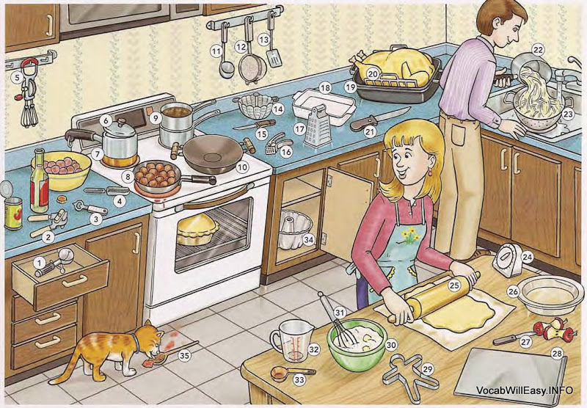

1 ice cream scoop  2 can opener   3 bottle opener   4 (vegetable) peeler

5 (egg) beater  6 lid/cover/top   7 pot   8 frying pan/skillet

9 double boiler   10 wok  11 ladle    12 strainer

13 spatula   14 steamer   15 knife   16 garlic press

17 grater  18 casserole dish    19 roasting pan   20 roasting rack

21 carving knife 22 saucepan   23 colander   24 kitchen timer

25 rolling pin   26 pie plate   27 paring knife   28 cookie sheet

29 cookie cutter   30 (mixing) bowl  31 whisk  32 measuring cup

33 measuring spoon   34 cake pan  35 wooden spoon

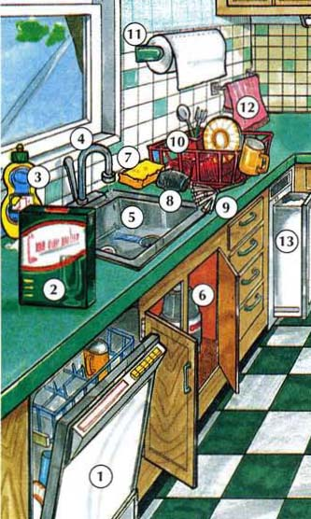

1. dishwasher 2. dishwasher detergent 3. dishwashing liquid

4. faucet  5. (kitchen) sink  6. (garbage) disposal

7. sponge  8. scouring pad  9. pot scrubber

10. dish rack   11. paper towel holder  12. dish towel

13. trash compactor 14. cabinet  15. microwave (oven)  16. (kitchen) counter

17. cutting board  18. canister  19. stove/range  20. burner   21. Oven

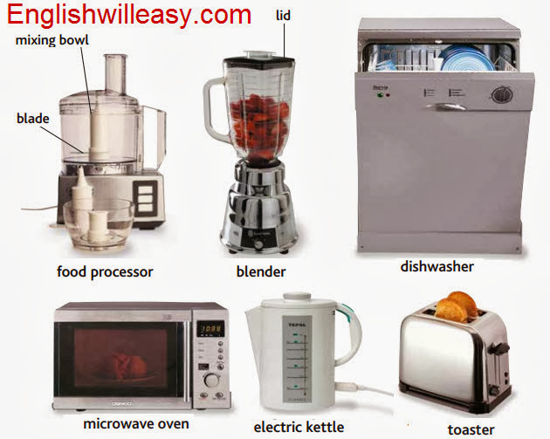

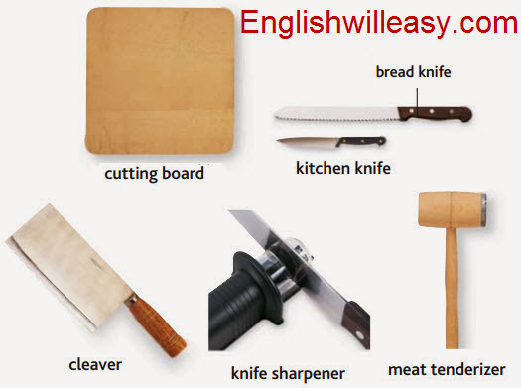

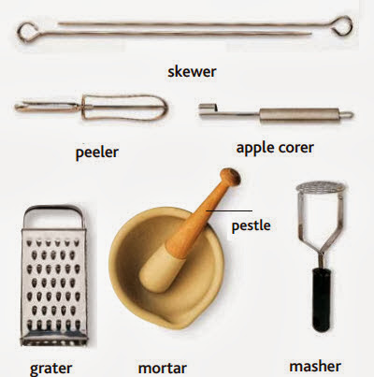

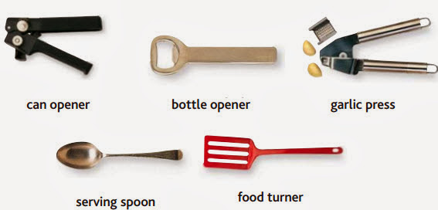

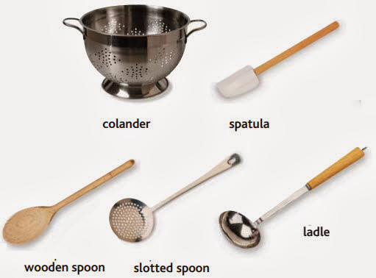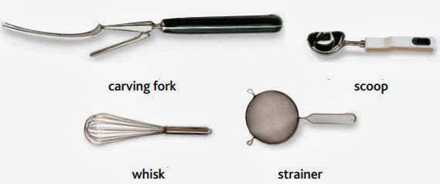

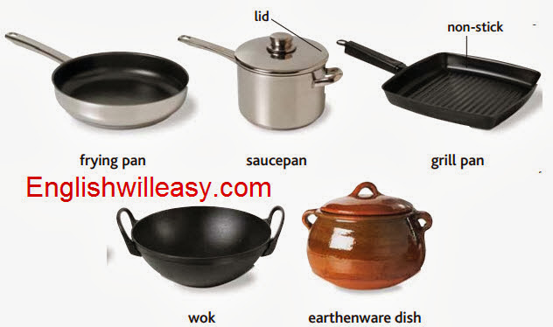

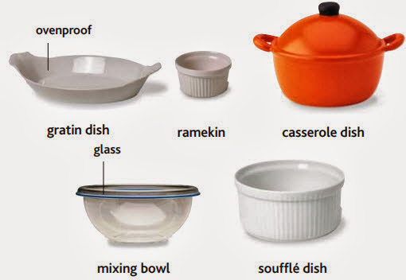

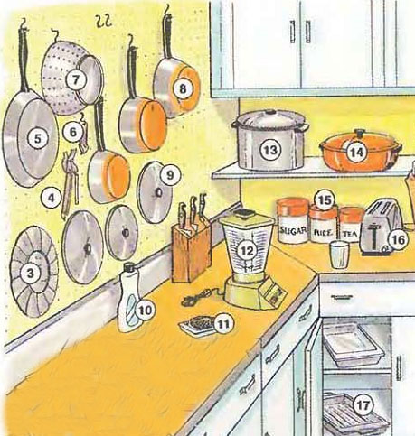

1. dishwasher   2. dish drainer 3. steamer   4. can opener   5. frying pan

6. bottle opener   7. colander  8. saucepan

9. lid   10. dish washing liquid   11. scouring pad

12. blender   13. pot   14. sasserole dish 15. canister  16. toaster  17. roasting pan

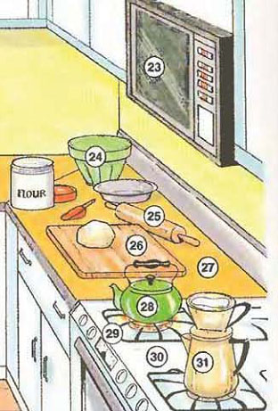18. dish towel   19. refrigerator  20. freezer

21. ice tray   22. cabinet

23. microwave oven 24. mixing bowl  25. rolling pin

26. cutting board 27. counter  28. teakettle

29. burner  30. stove   31. Coffeemaker

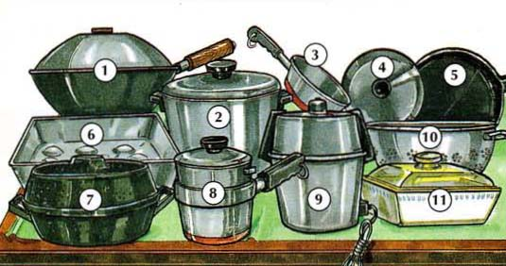1. wok  2. pot  3. saucepan  4. lid/cover/top  5. frying pan/skillet

6. roasting pan  7. roaster  8. double boiler  9. pressure cooker

10. colander   11. casserole (dish)

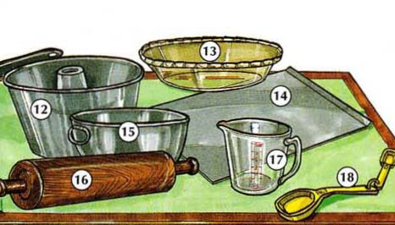

12. cake pan  13. pie plate  14. cookie sheet

15. (mixing) bowl  16. rolling pin  17. measuring cup

18. measuring spoon

